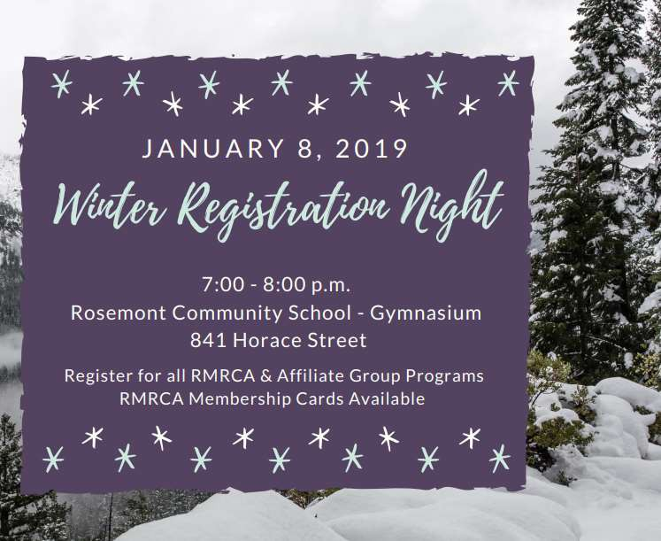

VOL. 63 Winter Newsletter January 2019

Inside This Issue:
• Hello 2019! …………………… 2
• Support Your Community - Become a Member….……………………………………. 3
• RMRCA Annual General Meeting …………………………………..…………………. 3
• Winter Programs ………………………………………………………………………... 4
• Rosemont Outdoor Ice ….…………………………………………….………………… 6
• Sidewalk Snow & Ice………… 6

www.rmrca.com

We have great things in store
for 2019 but as we look to the
year ahead we can’t help but
think about the year we just
had…and what a year it was!!

RMRCA celebrated 30 years of serving the Rosemont and Mount Royal communities - what a milestone. Annually this group of volunteers donates over 1,400 hours to bringing
programs and event to the 4,000 community households that calls Rosemont and Mount Royal home.

2018 was a year of bringing community together. Focus was put on communications and during a summer of increased break in and vandalism activity, the need for more “real time”
information sharing was needed and a Community driven
Facebook community emerged. Growing to over 2,000
followers, the Community was able to communicate directly
with each other and watch out for their neighbors. RMRCA also
opened discussions with the Regina Police Services (RPS) about
the increased crime activity, looking for advice on how residents
can protect their property. RMRCA looks to plan an
engagement session with the Community and RPS sometime in
the spring of 2019, to help residents remain informed of crime
activity.

The RMRCA also added a Spring Newsletter bringing the total
to 3 annually. The E-News is also a great way for RMRCA to
get news out to the residents and in 2018 we saw our email list
grow to over 450. Get your name on the list and stay informed
of events and programs that pop up monthly - request to be
added by emailing rmrca@myaccess.ca.
We didn’t stop with just the Community. RMRCA spent a great deal of time working to get to know our partner Community

Get Involved - Volunteer With Us!

he RMRCA is always welcoming individuals that are
Associations in the West Zone. With similar challenges,
RMRCA feels that a stronger working relationship is needed to
continue to keep our communities vibrant and with services for
its residents. We have also been attending various City of
Regina “open houses” to keep abreast of City changes that can
impact our community. We will continue to foster these
relationships.
The Association was glad to help Walker School Parent
Committee with their efforts to fundraise for a new school yard
play structure. The Committee ran the canteen for the Winter
Craft Fair in November as well as helped RMRCA with set up
for the event. They raised over $350.00 to go towards the play
structure.

Last year, over 2,100 people used the outdoor ice rink on 4th
Avenue! Did you know that RMRCA supervises that rink and
makes sure that the shack is open and warm every night during
the winter season? Thank you to our Volunteers and to everyone who uses the rink. RMRCA is working with the City to get
some improvements made to the shack so that it remains open to the public.

RMRCA was happy to award Margaret Wah Ta a $500.00 Student Volunteer Scholarship. We have 2 to give away
annually and encourage all residents attending post-secondary education to apply. See www.rmrca.com to find information on the 2019 Scholarships.

So what do we have in store for 2019?? Stay tuned! Get on the ENews list and follow us on FB!

Thank you Rosemont Mount Royal for continuing to support your Community Association!

2. Newsletter Editor (Contracted): Responsible for the
development of the community newsletter generated three

T
interested in helping to shape our community.
times per year. (Email tmcquoid@rentvictory.com for more information)

There are a number of Board positions available, as well as a
need for event volunteers. All Board positions are for a term of
2 years. The RMRCA Board meets the first Tuesday of each month, at 7:00 p.m. at the Rosemont Community School from September to June.

Available positions are -
1. Directors: Directors are voting members of the Board that
can lead sub-committees based on their interest. The RMRCA Executive is also filled from the Board Directors such as Chair, Vice, Treasurer and Secretary.
3. Event Volunteers: Volunteers are needed to assist with
the community events that we hold. This can include set up/clean up, running registration tables, coordinating
vendors, etc. Volunteers can participate as available.

More detailed information for all RMRCA Board positions can be found on our website at www.rmrca.com.

RMRCA represents the citizens of Rosemont and Mount Royal - all community members are more than welcome to attend a meeting.

www.rmrca.com Page 2

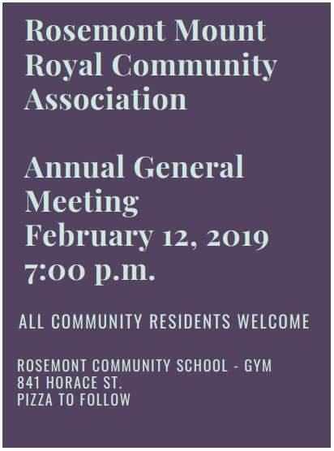Support your Community - Become a RMRCA Member!

F

or over 30 years, the Rosemont Mount Royal Community Association has worked to bring a variety of sport,

RMRCA Membership Card

recreation, culture and social programs to the people of this Community. Serving over 4,000 homes makes the RMRCA one of the largest community associations in the City of Regina!
RMRCA also depends on the Family Memberships that are sold
each year to the Community. RMRCA uses these funds to keep
your community vibrant by bringing the events and programs
that you want to the area. Funds are also used to make donations to neighborhood schools and charitable organizations; to provide scholarships to youth volunteers and to print newsletters to keep you informed… just to name a few!
Becoming a member of the Rosemont Mount Royal Community Association is a great way to support your community, the
Association, and to stay informed about RMRCA programs and events.
A RMRCA Family Membership is available to any family or individual for a small price of $5.00 and is valid for one year, September 1 - August 31st.

Family memberships assist your Community Association in continuing their service to you.

2019 RMRCA Student Volunteer Scholarship

he RMRCA is pleased to offer a Volunteer
Community Association Membership entitles you and your family to participate in numerous programs
provided by our Community, other Communities, Zone Boards and Affiliated Groups.

One membership per family per year is required. Cost is $5. Bring this form to Registration Night, or mail thisform along with $5.00 to RMRCA Membership
Coordinator, 1034 Campbell St. Regina, SK. S4T 5P4.
Name: __________________________________
Address: ________________________________
Postal: ______________Phone: ______________
Email: __________________________________

Do you want to receive RMRCA Newsletter and Community updates by email? Y N
Thank you for supporting your Community Association!

T
Scholarship to students in this Community who

demonstrate their exceptional volunteer efforts not only in their school but in their community and city.
Awarded in June each year, two scholarships in the amount of $500.00 each are intended to assist students with postsecondary education costs.
Applications and volunteer resume must be submitted by May 15, 2019 in writing to RMRCA Treasurer 6109 5th Avenue, Regina, SK. S4T 6R8 or by email to
helen.adams@sasktel.net
RMRCA Student Volunteer Scholarship information can be
found at www.rmrca.com.

www.rmrca.com Page 3

RMRCA Winter 2019 Program Registration
January 8, 2019 7:00 p.m. - 8:00 p.m.
Rosemont Community School  Gymnasium  841 Horace Street

HOW TO REGISTER FOR RMRCA PROGRAMS AND OTHER CITY WIDE PROGRAMS
1. Attend the RMRCA program registration for residents of Rosemont and Mount Royal
2. Become a Community Member ($5.00 per household). Membership valid from September 1, 2018 - August 31, 2019.
3. For RMRCA programs: Register and pay for program(s) at the RMRCA registration night.
4. For other programs (run by other community associations): Register for programs at the RMRCA registration but do not pay. The
sponsoring organization will contact you and collect the appropriate fees.

RMRCA REFUND POLICY: All requests for refunds for RMRCA programs must be submitted in writing to the Treasurer prior to the 3rd (third) class. Requests will be reviewed by RMRCA Executive and will be considered for special circumstances on a prorated basis. All refunds are subject to a $10 administration fee. If classes are cancelled by RMRCA, a full refund will be issued. No refunds for
membership. Submit to: RMRCA Treasurer 6109 5th Avenue, Regina, SK S4T 6R8
Need Help? Anyone requiring financial assistance in order to register for any RMRCA programs should submit their request in writing
to: RMRCA 6109 5th Avenue Regina, SK. S4T 6R8 or helen.adams@sasktel.net

YOUTH PROGRAMS
BOUNCE & BALANCE 3-4 YEARS
Dates: Saturdays. Jan 26 - Apr 6, 2019 (No class Feb 23) Cost: $40.00 Time: 1:00 p.m. - 1:45 p.m.
Location: Rosemont Community School Gymnasium
NINJA GYM 5-6 YEARS
Dates: Saturdays, Jan 26 - Apr 6, 2019 (No class Feb 23) Cost: $40.00 Time: 2:00 p.m. - 2:45 p.m.
Location: Rosemont Community School Gymnasium
GYM COMBO 7-8 YEARS
Dates: Saturdays, Jan 26 - Apr 6 (No class Feb 23) Cost: $40.00 Time: 3:00 p.m. - 3:45 p.m.
Location: Rosemont Community School Gymnasium

BASKETBALL SKILLS & DRILLS 9-11 YEARS Dates: Mondays, Jan 21 - Apr 1, 2019 (No class Feb 18) Cost: $40.00 Time: 6:30 p.m. - 7:30 p.m.
Location: Walker School Gymnasium

BASKETBALL SKILLS & DRILLS 12-14 YEARS Dates: Mondays, Jan 21 - Apr 1, 2019 (No class Feb 18) Cost: $40.00 Time: 7:30 p.m. - 8:30 p.m.
Location: Walker School Gymnasium

10 -14 YEARS
My Time offers a variety of fun activities, including: art,
cooking, crafts, drama, games, sports, theme nights and
more! My Time is a City of Regina program, funded by the
RMRCA - everyone in our community is welcome to take part!
Dates: Tuesdays & Thursdays, Jan start TBD Cost: Free (Participant Forms required to participate) Time: 6:30 p.m. - 8:30 p.m.
Registration: Jan 8, onsite on first night, or call Sean Sullivan (306)777-7146 to register and for more information. Location: Rosemont Community School Gymnasium
ADULT PROGRAMS
ZUMBA 18+ YEARS
Dates: Wednesdays, Jan 23 - Apr 3, 2019 (No class Feb 20) Cost: $40.00 Time: 7:00 p.m. - 8:00 p.m.
Location: Martin Collegiate Lunch Room
GENTLE YOGA 18+ YEARS
Dates: Mondays, Jan 21 - Apr 1, 2019 (No classes Feb 18) Cost: $40.00 Time: 7:00 p.m. - 8:00 p.m.
Location: Martin Collegiate Lunch Room
YOGA FLOW 18+ YEARS
Dates: Mondays, Jan 21 - Apr 1, 2019 (No classes Feb 18) Cost: $40.00 Time: 8:15 p.m. - 9:15p.m
Location: Martin Collegiate Lunch Room
BODY SCULPT 18+ YEARS
Dates: Sundays, Jan 27 - Apr 7, 2019 (No class Feb 24) Cost: $40.00 Time: 10:00 a.m. - 11:00 a.m.
Location: Rosemont Community School Gymnasium
PIYO 18+ YEARS
Dates: Tuesdays, Jan 22 - Apr 2, 2019 (No class Feb 19) Cost: $40.00 Time: 7:00 p.m. - 8:00 p.m.
Location: Martin Collegiate Lunch Room
55+ PROGRAMS
FOREVER... IN MOTION: This program includes endurance, strength, balance and flexibility activities which may be performed either in the sitting or standing positions. Registration at first class.
Two Class Options:
• Mondays, Jan 7 - May 13, 2019 (No class Feb 18;
Apr 22)
• Fridays, Jan 11 - May 17 (No class April 19)
Cost: Free with Community Membership (pre-registration preferred)
Time: 10:00 a.m. - 11:00 a.m.
Locations: St. James Anglican Church

www.rmrca.com Page 4

OTHER
COURT WHIST 18+ YEARS Dates: Every 2nd Thursday, Start date TBA Cost: By Donation Time: 7:30 p.m. Location: Christ Lutheran Church
Contact Roberta (306)543-1958 for the start dates.

ESL (ENGLISH AS A SECOND LANGUAGE)
18+ YEARS

Brought to you by the RMRCA for the residents of this Community. Registrations are required and will only be accepted until class is full, space is limited.
Dates: Tuesdays, Jan 22 - Mar 5, 2019 (No class Feb 19)
Cost: Free with Community Membership (pre-registration
required)
Time: 6:30 p.m. - 8:30 p.m.
Location: Martin Collegiate, Elder’s Room
ARTS & CRAFTS
LEARN TO CROCHET 18+ YEARS
Dates: Wednesdays. Jan 23 - Mar 6, 2019 (No class Feb 20) Cost: $40.00 plus supplies
Time: 7:00 p.m. - 8:30 p.m.
Location: Martin Academy, Elder’s Room
WEST ZONE BOARD & AFFILIATE
PROGRAMS (COMMUNITY MEMBERSHIP REQUIRED) REGINA WEST ZONE OUTDOOR SOCCER
Co-ed, no-cut recreational soccer for ages three to nineteen. Games played May - June ending in tournament in June. Older age groups play with other zones throughout City.
Cost: See website
Register: Online registration begins January 2019. Registration Deadline: March 15, 2019
Online: www.rwzsa.ca
In Person: Saturday, March 2, 2019 10:00 a.m. - 1:00 p.m. at the North West Leisure Centre
Registration Inquiries: www.rwzsa.ca
Referees Needed: Referees needed for age groups 8U and higher. Applications available on website or at the West Zone Board office, wzb@sasktel.net. Applications due Mar 22,
2019

REGINA WEST ZONE TAEKWON-DO West Zone
Taekwon-Do offers classes focused towards a recreational
family program for fitness, co-ordination and self-discipline,
while learning the art of Taekwon-Do Self Defence. Instructed by Master Clint Norman (ITF 8th Dan Black Belt) and his
assistants provide instruction.
TRY OUT FOR FREE: Attend any beginner class.
Ongoing Registration Winter/January; Spring/April
Cost: $350/3 month session (incl. dobok, manual, fees and ITF Membership)
Location: Henry Janzen School - 222 Rink Avenue Class Time: Beginner
• Sunday: Beginner 1:00 - 2:00 pm ; Intermediate 2:00 -
3:00pm; Senior 2:00 - 3:00 pm
• Monday: Beginner 6:00 - 7:00 pm; Intermediate 7:00-
8:00 pm; Senor 8:00 - 9:00 pm
• Wednesday: Beginner 6:00 - 7:00 pm; Intermediate 7:00
- 8:00 pm; Senior 8:00 - 9:00 pm
For further information contact Regina West Zone Taekwondo at wztaekwondo@gmail.com, 306-525-0005 or contact the
West Zone Board office at wzb@sasktel.net, 306-791-0226.
T-BALL/SOFTBALL
No-cut, equal participation sports program.
Registration: Online at www.rnwsa.ca by February 2019 In Person: Saturday
• March 16, 2019 2:30 - 3:30 p.m.
• April 13, 2019 2:30 - 3:30 p.m.
Cost: See website for cost. Community Membership required. Umpires Needed: Paid umpires needed for all divisions
except T-ball and A-ball
LEARN TO SKATE
Teaches children to stand and walk on skates and feel comfortable on ice. Skating/Hockey helmet with full face guard is mandatory.
Ages: 3-12 years. Class dates/times/rink can be found on website.
Registration: January 7, 2019, 9:00 a.m. West Zone Board office at North West Leisure Centre.
Registrations will be accepted until classes are full. Classes often fill first day of registration. More information can be
found on website www.westzoneboard.ca
Cost: $85.00 (8 classes/session).

The Ehrlo Outdoor Hockey League (OHL) offers free
recreational opportunities for families who are unable to
participate in traditional, organized sports. All equipment is provided thereby eliminating the need for hard-to-afford
purchases like helmets, pads and skates.
OHL will be at the Rosemont outdoor rink -
Wednesdays January 9th - March 6, 2019
6: 30 p.m. - 8:30 p.m. Atom (Ages 6-11)
7:30 - 8:30 Bantam (Ages 12-16)
Weather permitting
To register or book a fitting time for equipment please call (306) 751-2411; Facebook: Ehrlo Sport Venture; or website www.ehrlo.com/sport -venture
Supervision of rink shelter is provided by Rosemont Mount Royal Community Association

www.rmrca.com Page 5

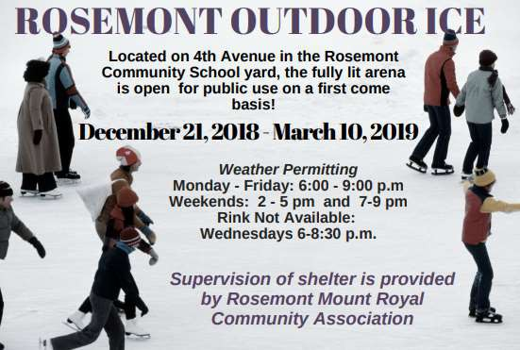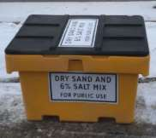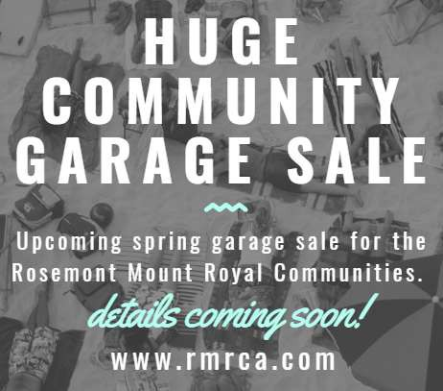

City of Regina Residential Sidewalk Snow & Ice
Removal

Snow and ice on residential
sidewalks is the responsibility of
the property owner/resident.

It’s important to keep your
sidewalks shoveled and sanded
to help pedestrians walk safely
and easily down the street.
Snow from resident’s driveways and walkways should be
stored on their private yard, not on streets, sidewalks or
boulevards.

The City provides sand at various locations throughout
Regina for residents who need it to make icy sidewalks and
driveways safe. You must bring a container and something to
scoop with.
In Rosemont and Mount Royal, the City of Regina Sand Box is located at the Jack Hamilton Area, 1010 McCarthy Blvd. near the tennis courts.
Thank you for keeping our Community sidewalks safe for all to use!

www.rmrca.com Page 6

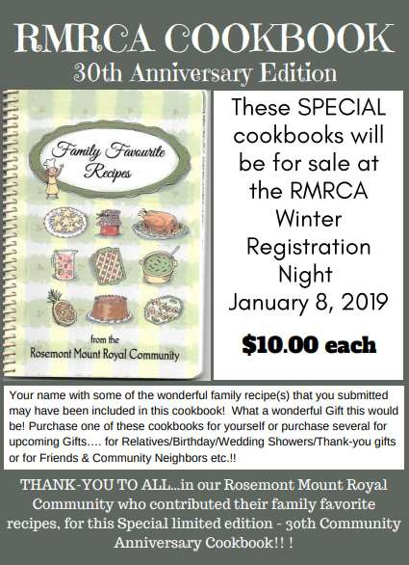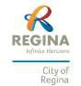

RMRCA Board of Directors - 2019/2020
Chairperson Theresa McQuoid 306-535-5595 tmcquoid@rentvictory.com
Vice Chair Alex Tkach alex.tkach@frqentertainment.ca
Secretary Donna Inverarity donna.inverarity@sasktel.net
Treasurer Helen Adams 306-543-9152 helen.adams@sasktel.net
Membership Susan Bogues 306-949-1370
Outdoor Sign Glen Nichol 306-949-3195 cgnichol@sasktel.net
Facilities Helen Adams 306-543-9152
Social Coordinator Marianna Topos Marianna_11@hotmail.com
Communications Alex Tkach alex.tkach@fqentertainment.ca
Promotions Elaine Dittmann 306-543-4402 edittmann@sasktel.net
Newsletter Editor Theresa McQuoid tmcquoid@rentvictory.com
West Zone Board Rep Andrew Nestor Andrew.nestor@staples.ca
Member-at-large Steve Bogues
Dan Riess driess@hotmail.com

Programs Coordinator Theresa Porter tbaum3@hotmail.com
City of Regina Wendy Dumalski 306-777-7362 wdumalsk@regina.ca
For General Inquiries email: rmrca@myaccess.ca

The Rosemont Mount Royal Community Association would like to thank the City of Regina for
being our “program partner” by helping us bring the community these great programs and activities
- we really appreciate the support!
Thank you!

www.rmrca.com Page 7

www.rmrca.com Page 8

