VOL. 65 | Fall Newsletter September 2019
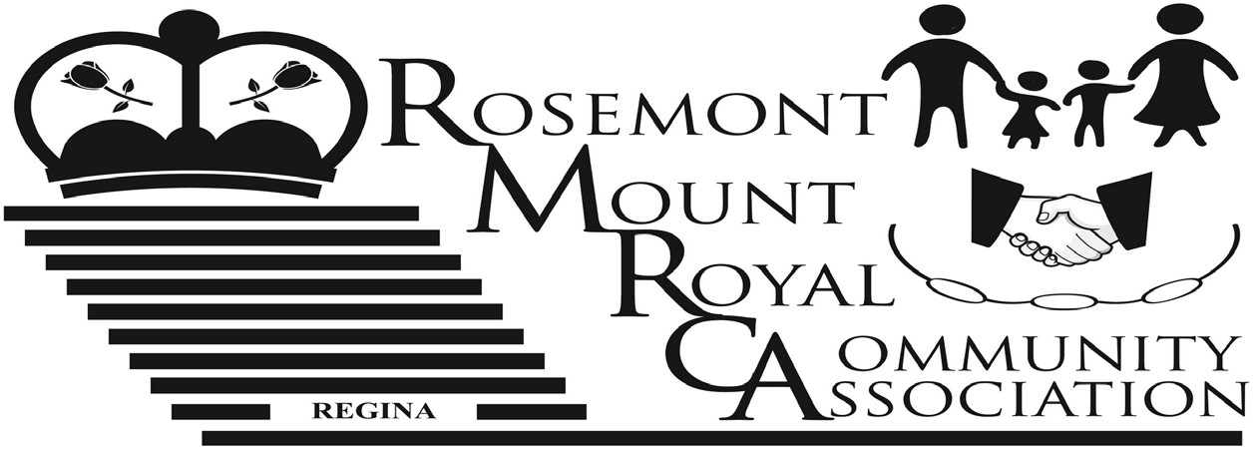
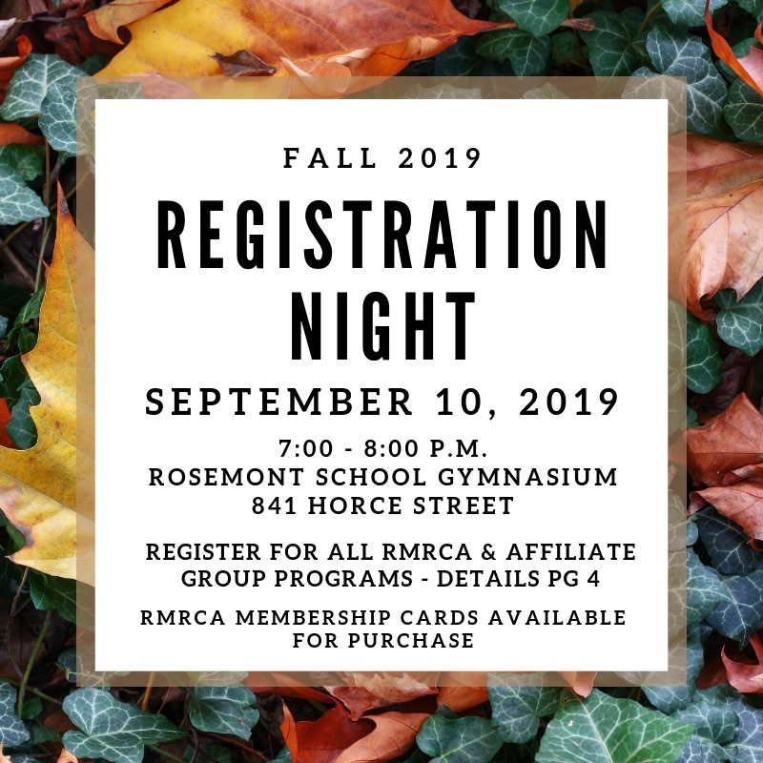

Inside This Issue:
- Buy a Membership – Support Your Community ............................................................................ 2
- Keeping Rosemont Safe ……….…………………………………………………………………. 2 • RMRCA Star Party ………………………………………………………….…………………. 3 • Fall Programs …………………………………………………………………………………..…. 4
- RMRCA Contact Information ……………………………………………………………………. 7

Become A RMRCA Volunteer!
RMRCA is always welcoming individuals that are interested in helping to shape our community and relies on the support of volunteers for nearly everything we do! There are many ways to volunteer and RMRCA is always looking for engaged community members to contribute their time and energy towards making Rosemont and Mount Royal an even better place to live and work.

There are a number of Board positions available – All Board positions are for a term of 2 years and meet monthly September – June. If your time commitment won’t allow that – the RMRCA always welcomes event volunteers!

Event Volunteers are needed to assist with the community events that we hold. This can include set up; clean up, running registrations, etc. Volunteers can participate as their time allows. Some of the 2019/2020 events that require volunteers are Star Party (September), Winter Craft Fair (November), Winter Outdoor Fun (December) Family Fun Day (April) plus more! This is just a selection of things we are looking for help with – we are always open to hearing from new volunteers!

If you have questions about volunteer opportunities with
Buy a Membership – Support Your Community

RMRCA please contact us at www.rmrca.com

For over 30 years, the RMRCA has worked to bring a variety of sport, recreation, culture and social programs to the people of this Community. Serving over 4,000 homes makes the RMRCA one of the largest community associations in the City of Regina!

RMRCA depends on the Family Memberships that are sold each year to the Community. RMRCA uses these funds to keep your community vibrant by bringing the events and programs that you want to the area. Funds are also used to make donations to neighborhood schools and charitable organizations; to provide scholarships to youth volunteers and to keep you informed… just to name a few!

Becoming a member of the Rosemont Mount Royal Community Association is a great way to support your community, the Association, and to stay informed about RMRCA programs and events. Even if you don’t take part in any of the events or programs, you can still support your Community!

Keeping Rosemont and Mount Royal A Safe Place – RMRCA
Partners with Dieppe-Westerra Community Association

A RMRCA Family Membership is available to any family or individual for a small price of $5.00 and is valid for one year, September 1 – August 31st. Memberships can be purchased at the Registration Night; Online at www.rmrca.com; or by printing the form on Pg. 6 and mailing it in as directed. Might just be the best $5 you spent this year!

We have all heard the news about an increase in property crime within the City. Crime is noticeably up this summer across Regina and like other communities Rosemont Mount Royal is having their share in theft and mischief problems.

The RMRCA participated in an Open House Meeting with the RPS, City of Regina and West Zone Board in June to allow the residents a chance to communicate with representatives about their concerns. The Open House was well attended and all participants left with helpful information.

This summer, RMRCA partnered with Dieppe-Westerra
Community Association in a pilot initiative that would focus on safety specific to our areas. Impact Security was hired as
part of the pilot to provide additional security directly to the communities of Rosemont, Mount Royal, Dieppe and Westerra.

Patrolling since June, Impact has created a presence in the area, reporting nightly on any activities. In some instances, working with RPS to stop property theft.

To improve efficiencies, and get the most from the pilot, an online form has been developed, http://bit.ly/rmrcaimpact This form allows residents to log concerns in their specific area. This form is meant to provide Impact Security with information as to where problems are occurring. This is not a police report – please contact RPS directly so that they may properly investigate.

We, as residents, still have a part to play - be alert to any suspicious activity in your area and report these incidents by calling the Regina Police Service Communications Center at 777-6500 or in an emergency call 9-1-1.

www.rmrca.com | Page 2

Regina Community Needs Assessment – Your Feedback is

Important

In collaboration with the West Zone Board and other Community Association’s in Regina, RMRCA is helping drive a city wide Community Needs Assessment that will help provide direction on tackling what issues are impacting you and your family the most.

By filling out this short 5 minute survey, http://bit.ly/RNASurvey, or the QR Code to right, you will be providing insight into the community we represent as well as provide you an opportunity to tell us how your community association and the City of Regina can better serve you.
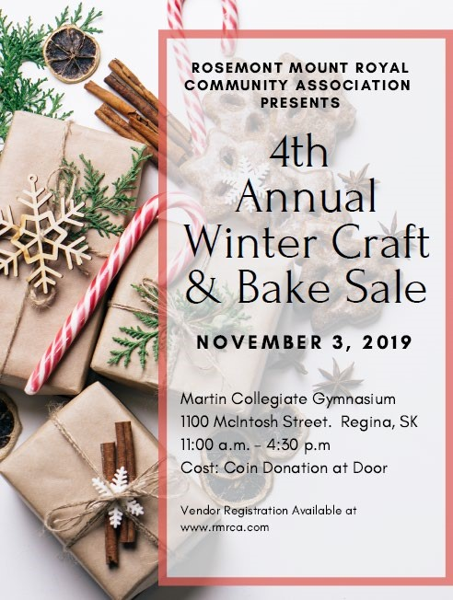
This needs assessment has no direct affiliation with the City of
Regina and is being done as an interzone board collaboration project to gauge the needs of the communities we represent. This survey can be
anonymous and we encourage every
resident to fill it out as getting more in touch with the community is one of our goals.

Thank you in advance and we appreciate any feedback you can provide, good or bad!
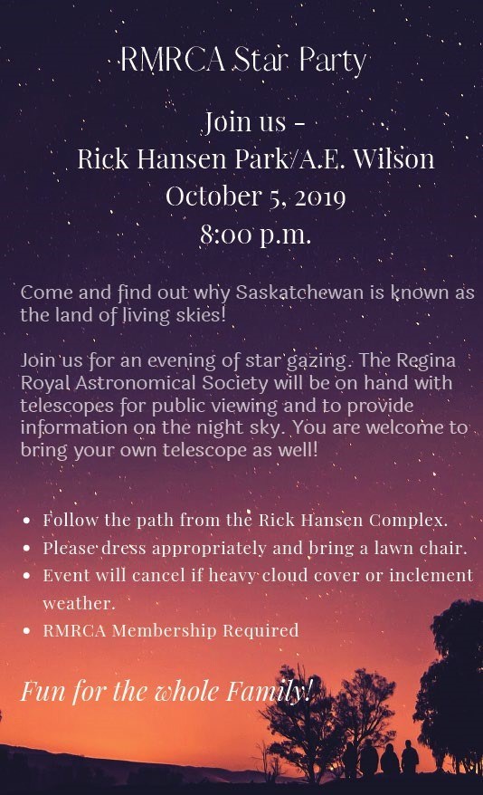

www.rmrca.com | Page 3

RMRCA Fall 2019 Program Registration
September 10, 2019 7:00 p.m. – 8:00 p.m.
Rosemont Community School  Gymnasium  841 Horace Street

PAYMENT OPTIONS: CASH OR CHEQUE

HOW TO REGISTER FOR RMRCA PROGRAMS AND OTHER CITY WIDE PROGRAMS
- Attend the RMRCA program registration for residents of Rosemont and Mount Royal
- Become a Community Member ($5.00 per household). Membership valid from September 1, 2019 – August 31, 2020.
- For RMRCA programs: Register and pay for program(s) at the RMRCA registration night.
- For other programs (run by other community associations): Register for programs at the RMRCA registration but do not pay. The sponsoring organization will contact you and collect the appropriate fees.

RMRCA REFUND POLICY: All requests for refunds for RMRCA programs must be submitted in writing to the Treasurer prior to the 3rd (third) class. Requests will be reviewed by RMRCA Executive and will be considered for special circumstances on a prorated basis. All refunds are subject to a $10 administration fee. If classes are cancelled by RMRCA, a full refund will be issued. No refunds for membership. Submit to: RMRCA Treasurer 6109 5th Avenue, Regina, SK S4T 6R8

Need Help? Anyone requiring financial assistance in order to register for any RMRCA programs should submit their request in wiring to: RMRCA 6109 5th Avenue Regina, SK. S4T 6R8 or helen.adams@sasktel.net

YOUTH PROGRAMS

BOUNCE & BALANCE 3-4 YEARS
Dates: Saturdays. Sept 28 – Nov 30, 2019
Cost: $40.00 Time: 1:00 p.m. – 1:45 p.m.
Location: Rosemont School (Gym)

NINJA GYM 5-6 YEARS
Dates: Saturdays, Sept 28 – Nov 30, 2019
Cost: $40.00 Time: 2:00 p.m. – 2:45 p.m.
Location: Rosemont School (Gym)

BALLET/BATON 5-7 YEARS
Dates: Mondays, Sept 23 – Dec 9, 2019 (no class Oct 14,
Nov 11)
Cost: $40.00 Time: 6:30p.m. – 7:30 p.m.
Location: Walker School (Gym)

KIDS CRAFTS 7-12 YEARS
Dates: Saturdays, Sept 28– Nov2, 2019
Cost: $60.00 Time: 3:00 p.m. – 4:00 p.m.
All supplies provided, new craft each week
Location: Rosemont School (Gym)

JAZZ/BATON 8-10 YEARS
Dates: Mondays, Sept 23 – Dec 9, 2019 (no class Oct 14,
Nov 11)
Cost: $40.00 Time: 7:30 p.m. – 8:30 p.m.
Location: Walker School (Gym)

BASKETBALL SKILLS 9-11 YEARS
Dates: Tuesdays, Sept 24- Nov 26, 2019
Cost: $40.00 Time: 6:30 p.m. – 7:30 p.m.
Location: Walker School (Gym)

ZUMBA 11-14 YEARS
Dates: Wednesdays, Sept 25-Nov 27, 2019
Cost: $35.00 Time: 6:45 p.m. – 7:30 p.m.
Location: Martin Collegiate (Lunch Room)

10 -14 YEARS
My Time offers a variety of fun activities, including: art, cooking, crafts, drama, games, sports, theme nights and more! My Time is a City of Regina program, funded by the RMRCA - everyone in our community is welcome to take part!

Dates: Tuesdays & Thursdays Oct 2 – Dec 6, 2019 Cost: Free (Participant Forms required to participate) Time: 6:30 p.m. – 8:30 p.m.
Registration: Oct 1, onsite on first night, or call Sean Will (306)777-7146 to register and for more information.
Location: Rosemont School (Gym)

ADULT PROGRAMS

ZUMBA 18+ YEARS
Dates: Wednesdays, Sept 25 – Nov 27, 2019
Cost: $45.00 Time: 7:30 p.m. – 8:30 p.m.
Location: Martin Collegiate (Lunch Room)

GENTLE YOGA 18+ YEARS
Dates: Mondays, Sept 23 – Dec 9, 2019 (No classes Oct 14;
Nov 11)
Cost: $45.00 Time: 7:00 p.m. – 8:00 p.m.
Location: Martin Collegiate (Lunch Room)

HATHA FLOW YOGA 18+ YEARS
Dates: Mondays, Sept 23 – Dec 9, 2019 (No classes Oct 14;
Nov 11)
Cost: $45.00
Time: 8:15 p.m. – 9:15p.m
Location: Martin Collegiate (Lunch Room)

HIIT & BURN 18+ YEARS
Dates: Thursdays, Sept 26-Dec 5, 2019 (No classes Oct 31)
Cost: $45.00 Time: 6:30 p.m. – 7:30 p.m.
Location: Martin Collegiate (Lunch Room)

PIYO 18+ YEARS
Dates: Tuesdays, Sept 24 – Nov 26, 2019
Cost: $45.00 Time: 7:00 p.m. – 8:00 p.m.
Location: Martin Collegiate (Lunch Room)

BODY SCULPT 18+ YEARS
Dates: Sundays, Sept 29 – Dec 1, 2019
Cost: $45.00 Time: 9:00 a.m. – 10:00 a.m.
Location: Rosemont School (Gym)

55+ PROGRAMS
FOREVER... IN MOTION: This program includes
endurance, strength, balance and flexibility activities which may be performed either in the sitting or standing positions.
Registration at first class.

Three Class Options:
- Mondays, Sept 9 – Dec 16, 2019
- Wednesdays, Sept 11 – Dec 18,2019
- Fridays, Sept 13 – Dec 20, 2019
Cost: Free, Community Membership required. Preregistration preferred Time: 10:00 a.m. – 11:00 a.m.
Locations: St. James Anglican Church

OTHER
COURT WHIST 18+ YEARS
Dates: Every 2nd Thursday, Start date TBA Cost: By Donation Time: 7:30 p.m.
Location: Christ Lutheran Church Contact Roberta (306)543-1958 for the start dates in September.

ESL (ENGLISH AS A SECOND LANGUAGE) 18+
YEARS Brought to you by the RMRCA for the residents of this Community. Registrations are required and will only be accepted until class is full, space is limited.

Dates: Tuesdays, Sept 24 - Nov 12, 2019 Cost: Free, Community Membership required. Preregistration required Time: 6:30 p.m. – 8:30 p.m.
Location: Martin Collegiate, (Room 1)

ASK ME ANYTHING – DROP IN TECHNOLOGY SESSION 18+ YEARS
Dates: Every 2nd Wednesday, Sept 25th – Nov 27, 2019
Cost: Free Time: 7:00 – 9:00 p.m.
Location: Rosemont School (Gathering Room 5) Session offers you general information on common devices, new topic each class, as well as allows you to ask questions.
Bring your device.

ARTS & CRAFTS

LEARN TO CROCHET 18+ YEARS
Dates: Wednesdays, Sept 25 - Oct 23, 2019 Cost: $45.00 plus supplies (list provided at registration night) Time: 7:00 p.m. – 8:30 p.m.
Location: Martin Collegiate (Room 1)

LEARN TO KNIT 18+ YEARS
Dates: Wednesdays, Oct 30 – Nov 27, 2019 Cost: $45.00 plus supplies (list provided at registration night) Time: 7:00 p.m. – 8:30 p.m.
Location: Martin Collegiate (Room 1)

WEST ZONE PROGRAMS (COMMUNITY MEMBERSHIP REQUIRED)

REGINA WEST ZONE INDOOR SOCCER
Co-ed, no-cut recreational soccer for ages three to nineteen.
Games on Saturdays from mid-October to March. Age groups 4U-10U receives shirts and team pictures and play in a winter tournament. All teams play an end of season tournament. Early registration assists league volunteers to organize the teams. Late registrations may not be accepted. Non- marking gym shoes and shin guards are required.

Cost: 4U $105; 6U-10U $115; 12U-19U $155
Register: In person Saturday Sept 7 10:00 – 1:00p.m. at
North West Leisure Centre
Online: www.reginaindoorsoccer.ca
Mail: Mail or drop off at West Zone Board (located in North
West Leisure Centre)
RWZISA
Box 35022, Sherwood Village RPO
Regina, Saskatchewan S4X 4C6

Payment: Cash will only be accepted at the in-person registration on Sept 7. All other off-line registrations must be made by cheque. Community Membership required ($10.00)
Registration Inquiries: registrar@reginaindoorsoccer.ca

All teams must have volunteer coaches! Please sign up for coach and/or assistant positions. For more information on the rewards of coaching please visit our website, www.reginaindoorsoccer.ca.

Our League runs on volunteer power! Parents, Persons or Groups needed to open/close gyms (daily honorarium paid). Contact call WZB (306) 791-0226 or infor@reginaindoorsoccer.ca for more information.

LEARN TO SKATE 3-12 YEARS
Teaches children to stand and walk on skates and feel comfortable on the ice. Skating/Hockey helmet with full face guard is mandatory.

Dates: Saturdays & Sundays Oct 6 – Dec 2, 2019 Ages: 3 - 12 years
Dates: Each age group has different dates. Forms available at www.westzoneboard.ca
Cost: $85.00/8 sessions. Plus community membership
($10.00)
Registration: Sept 5 - 14, 2019
See www.westzoneboard.ca for age groups, times, registration and location

REGINA WEST ZONE TAEKWON-DO West Zone
Taekwon-Do offers classes focused towards a recreational family program for fitness, co-ordination and self-discipline, while learning the art of Taekwon-Do Self Defence. Instructed by Master Clint Norman (ITF 8th Dan Black Belt) and his assistants provide instruction.

TRY OUT FOR FREE: Attend any beginner class

Fall Registration Oct 2 & 7, 2019 Cost: $350/First Time Registration (SFTI fee fundraising/Dobok/Manual incl.)
Location: Henry Janzen School – 222 Rink Avenue
Class Time: Beginner
Sunday: 1:00 – 2:00 pm

Monday: 6:00 – 7:00 pm
Wednesday: 6:00 – 7:00 pm
Class Time: Intermediate Sunday: 2:00 – 3:00 p.m.
Monday: 7:00 – 8:00 p.m.
Wednesday: 7:00 – 8:00p.m.
Class Time: Senior Sunday: 2:00 – 3:00 p.m.
Mondays: 8:00 – 9:00 p.m.
Wednesdays: 8:00 – 9:00 p.m.

For further information contact Regina West Zone Taekwondo at wztaekwondo@gmail.com, 306-525-0005 or contact the West Zone Board office at wzb@sasktel.net, 306-791-0226.
POWER SKATING:
Designed to improve and master skating techniques for both hockey and ringette players. Power skating is not only for straight line acceleration, but for all skating skill areas, backwards skating, tight glide turns, forward and backward crossovers, and more. Full hockey equipment required.

Registration & Procedures: Online Saturday Sept 14th www.rnwsa.ca
Programs and Cost: $295-$315. Costs vary by level. Full list online. Community Association Membership required ($10.00).
Date: Starts late October

LEARN TO PLAY HOCKEY
This class teaches the fundamentals of hockey. This is not a learn to skate program. Child must know how to skate and be born in a 2012-2014 to register.

Dates: 18 weeks, Sundays from Nov 2019 – March 2020 Time: 1:15 – 2:15 p.m., 2:15 – 3:15 p.m., 3:15 – 4:15 p.m. Register: Saturday Sept 14th, online www.rnwsa.ca Note: Full hockey equipment is required. Cost: $275 (jersey and socks included)
Visit www.rnwsa.ca for more information

RMRCA Membership Card
Community Association Membership entitles you and your family to participate in numerous programs provided by our Community, other Communities, Zone Boards and Affiliated Groups.

One membership per family per year is required. Cost is $5. Forms available online, at Registration Night, or by mailing this form along with $5.00 and a stamped self- addressed envelope (if return mail is needed) to RMRCA Membership Coordinator, 6109 5th Avenue Regina, SK. S4T 6R8.

Name: _________________________________________________________________________________
Address: _______________________________________________________________________________

Postal Code:__________________________________ Phone: ____________________________________

Email: __________________________________________________________________________________

Do you want to receive RMRCA Newsletter and updates by email? Y N

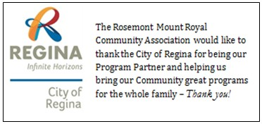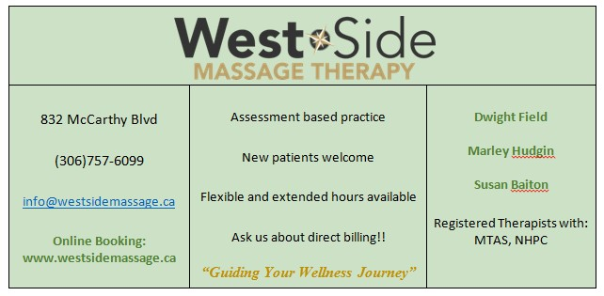
RMRCA Board of Directors – 2018/2019

Chairperson Theresa McQuoid 306-535-5595 tmcquoid@rentvictory.com
Vice Chair Alex Tkach alex.tkach@fqentertainment.ca
Secretary Dan Riess driess@hotmail.com
Treasurer Helen Adams 306-543-9152 helen.adams@sasktel.net
Membership Helen Adams 306-543-9152 helen.adams@sasktel.net
Outdoor Sign Glen Nichol 306-949-3195 cgnichol@sasktel.net
Facilities Helen Adams 306-543-9152 helen.adams@sasktel.net
Social Coordinator Dan Riess driess@hotmail.com
Communications Alex Tkach alex.tkach@fqentertainment.ca
Web Master Donna Inverarity donna.inverarity@sasktel.net
Promotions Elaine Dittmann 306-543-4402 edittmann@sasktel.net
Newsletter Editor Theresa McQuoid tmcquoid@rentvictory.com
West Zone Board Rep Andrew Nestor Andrew.nestor@staples.ca
Member-at-large Steve Bogues
Susan Bogues 306-949-1370
Reid Hill
Emma Trobiak
Marianna Topos Marianna_11@hotmail.com
Programs Coordinator Theresa Porter tbaum3@hotmail.com City of Regina Wendy Dumalski 306-777-7362 wdumalsk@regina.ca

EM: rmrca@myaccess.ca (General Inquiries) WB: www.rmrca.ca FB: RMRCA
www.rmrca.com | Page 7

www.rmrca.com | Page 8

