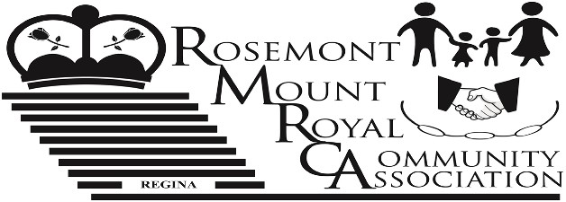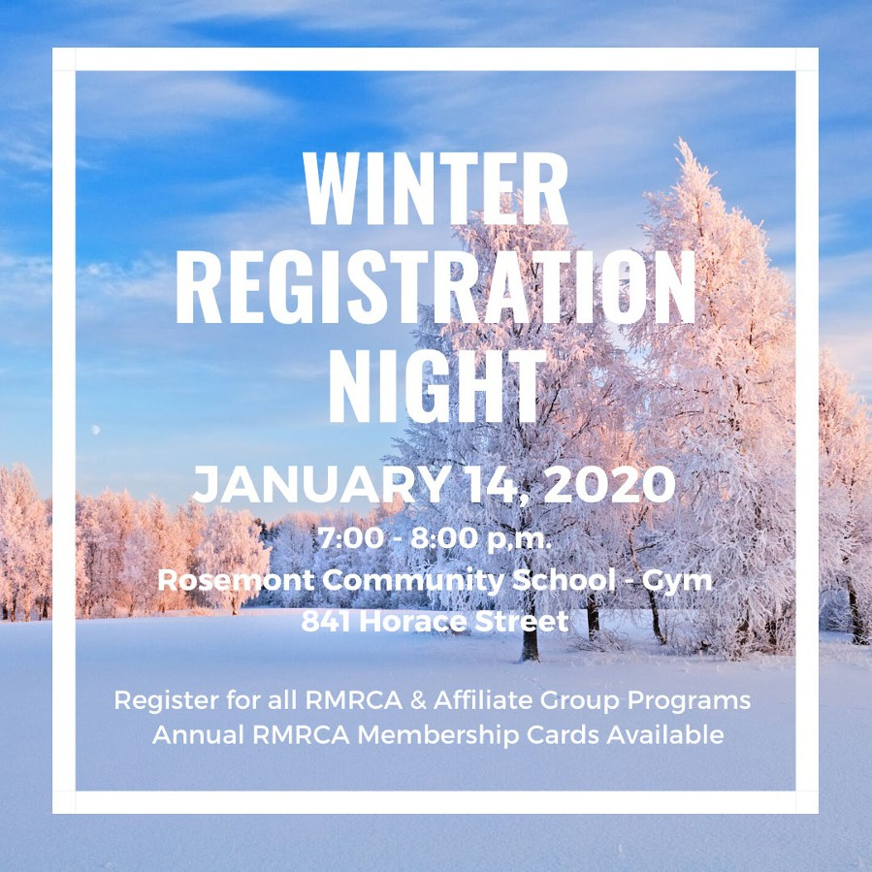

VOL. 66 Winter Newsletter January 2020

Inside This Issue:
• Buy a Membership - Support Your Community 2
• RMRCA Scholarship ……….……………………………………………………………………. 3
• Seniors Potluck …………………………………………………………………………………… 3
• Winter Family Day ……………………………………………………………………………….. 3
• Winter Programs …………………………………………………………….…………………... 4
• RMRCA Contact Information ……………………………………………………………………. 7

Happy New Year!

It’s very hard to believe that we are welcoming 2020 already! Time really does fly when you are having fun!! 2019 was a year of “Community” and RMRCA worked to bring
programs and events to the area that mattered to you.
Communications and safety was a large focus for the
RMRCA. In a time when vandalism reached uncomfortable highs, RMRCA fostered information sharing within our
community, with surrounding communities, and with our
community partners (RPS, City of Regina). This is successful
- the neighborhood is talking and looking out for each other!

RMRCA also partnered with Dieppe-Westerra Community Association in a pilot initiative that provided additional
security directly to the communities of Rosemont, Mount

Become A RMRCA Volunteer!

RMRCA is always welcoming individuals that are interested in helping to shape our community and relies on the support of volunteers for nearly everything we do! There are many ways to volunteer and RMRCA is always looking for engaged
community members to contribute their time and energy towards making Rosemont and Mount Royal an even better place to live and work.

There are a number of Board positions available - All Board positions are for a term of 2 years and meet monthly
September - June. If your time commitment won’t allow that – the RMRCA always welcomes event volunteers! Event
Royal, Dieppe and Westerra. This was successful and RMRCA is looking to continue this work in 2020.

Crawford’s No Frills has been an amazing Community
supporter, always lending support to initiatives within
Rosemont and Mount Royal. A huge thank you to Amber Crawford and staff of No Frill’s!

Last year over 3,000 people took part in our community
based programs. Alone, over 1,500 people used the outdoor
ice rink on 4th Avenue! RMRCA supervises that rink and
makes sure that the shack is open and warm every night
during the winter season. Thank you to our Community for
supporting the programs and events provided by RMRCA.

Volunteers are needed to assist with the community events
that we hold. This can include set up; clean up, running
registrations, etc. Volunteers can participate as their time
allows. Some of the 2020 events that require volunteers are Winter Outdoor Fun (February) Family Fun Day (April) Star Party (September), Winter Craft Fair (November), plus more! This is just a selection of things we are looking for help with -
we are always open to hearing from new volunteers!

If you have questions about volunteer opportunities with RMRCA please contact us at www.rmrca.com

Buy a Membership - Support Your Community

For over 30 years, the RMRCA has worked to bring a variety of sport, recreation, culture and social programs to the people of this Community. Serving over 4,000 homes makes the RMRCA one of the largest community associations in the City of
Regina!

RMRCA depends on the Family Memberships that are sold each year to the Community. RMRCA uses these funds to keep your community vibrant by bringing the events and programs that
you want to the area. Funds are also used to make donations to neighborhood schools and charitable organizations; to provide scholarships to youth volunteers and to keep you informed… just to name a few!
Becoming a member of the Rosemont Mount Royal Community Association is a great way to support your community, the
Association, and to stay informed about RMRCA programs and events. Even if you don’t take part in any of the events or
programs, you can still support your Community!

A RMRCA Family Membership is available to any family or individual for a small price of $5.00 and is valid for one year, September 1 - August 31st. Memberships can be purchased at the Registration Night; Online at www.rmrca.com; or by
printing the form on Pg. 6 and mailing it in as directed. Might just be the best $5 you spent this year!

www.rmrca.com Page 2

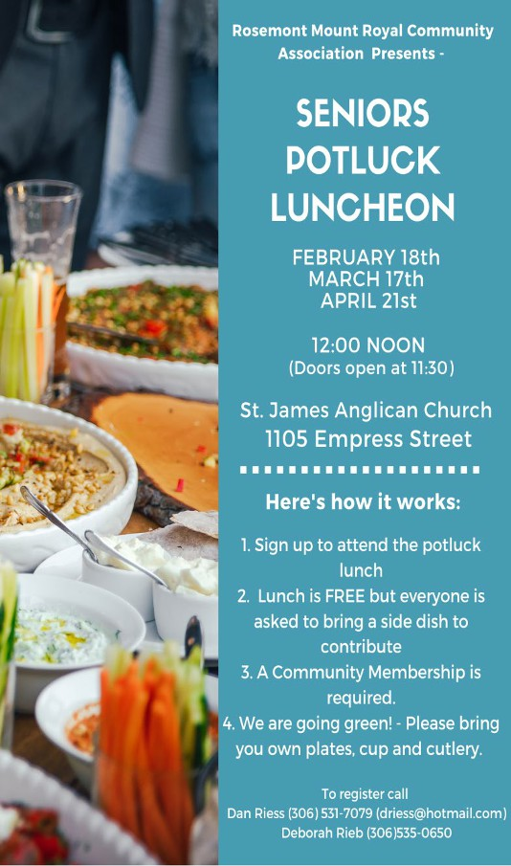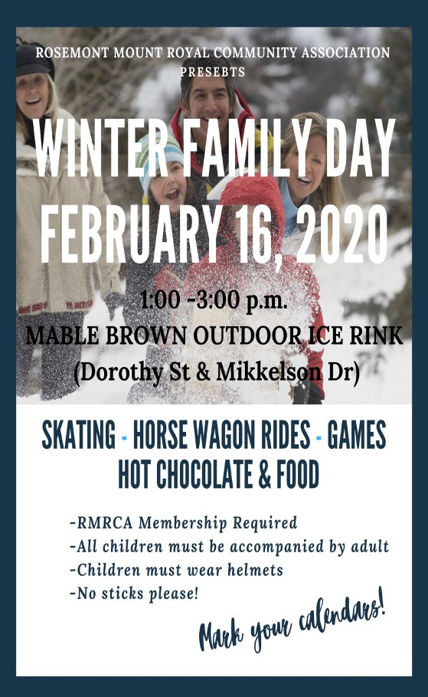2020 Student Volunteer Scholarships now available

RMRCA believes that volunteer involvement is an integral part of a strong and prosperous community. To encourage this value, the RMRCA rewards students who demonstrate outstanding volunteer involvement in their school, their community and City.
Two scholarships are available in the amount of $500 each! Students living in the Rosemount Mount Royal community can submit their resumes in writing by May 15th for a chance to be awarded one of the 2 scholarships in June.
To apply, simply submit you cover letter and resume which includes your name, email address and the name of the
current school and the Institution that you will be attending
for the 2020/2021 year. Resume must outline your volunteer
history as well as any current community involvement that
you participate in. Resume will also include the name and contact information of at least one (1) reference that can verify your volunteer involvement.
Scholarships are intended to assist students with post-
secondary education costs. Payment of scholarship will be
remitted upon proof of acceptance to a post-secondary
institution.
Deadline to apply is May 15, 2020. Please submit to RMRCA Treasurer 6109 5th Avenue, Regina, SK. S4T 6R8 or by email to helen.adams@sasktel.net.

Information can be found online at www.rmrca.comor by emailing rmrca@myaccess.com

www.rmrca.com Page 3

RMRCA Winter 2020 Program Registration
January 14, 2020 7:00 p.m. - 8:00 p.m.
Rosemont Community School  Gymnasium  841 Horace Street
PAYMENT OPTIONS: CASH OR CHEQUE
HOW TO REGISTER FOR RMRCA PROGRAMS AND OTHER CITY WIDE PROGRAMS
1. Attend the RMRCA program registration for residents of Rosemont and Mount Royal
2. Become a Community Member ($5.00 per household). Membership valid from September 1, 2019 - August 31, 2020.
3. For RMRCA programs: Register and pay for program(s) at the RMRCA registration night.
4. For other programs (run by other community associations): Register for programs at the RMRCA registration but do not pay.
The sponsoring organization will contact you and collect the appropriate fees.

RMRCA REFUND POLICY: All requests for refunds for RMRCA programs must be submitted in writing to the Treasurer prior to the 3rd (third) class. Requests will be reviewed by RMRCA Executive and will be considered for special circumstances on a
prorated basis. All refunds are subject to a $10 administration fee. If classes are cancelled by RMRCA, a full refund will be issued. No refunds for membership. Submit to: RMRCA Treasurer 6109 5th Avenue, Regina, SK S4T 6R8
Need Help? Anyone requiring financial assistance in order to register for any RMRCA programs should submit their request in
wiring to: RMRCA 6109 5th Avenue Regina, SK. S4T 6R8 or helen.adams@sasktel.net

YOUTH PROGRAMS
BOUNCE & BALANCE 3-4 YEARS
Dates: Saturdays. Jan 25 - Apr 4, 2020 (No class Feb 22) Cost: $40.00
Time: 1:00 p.m. - 1:45 p.m.
Location: Rosemont School (Gym)
NINJA GYM 5-6 YEARS
Dates: Saturdays, Jan 25 - Apr 4, 2020 (No class Feb 22) Cost: $40.00
Time: 2:00 p.m. - 2:45 p.m.
Location: Rosemont School (Gym)
KIDS CRAFTS 7-12 YEARS
Dates: Saturdays, Jan 25 - Apr 24, 2020 (No class Feb 22) Cost: $60.00
Time: 3:00 p.m. - 4:00 p.m.
All supplies provided, new craft each week Location: Rosemont School (Gym)

BASKETBALL SKILLS 9-11 YEARS
Dates: Tuesdays, Jan 28-Apr 7, 2020 (No class Feb 18) Cost: $40.00
Time: 6:30 p.m. - 7:30 p.m.
Location: Walker School (Gym)

10 -14 YEARS
My Time offers a variety of fun activities, including: art, cooking, crafts, drama, games, sports, theme nights and more! My Time is a City of Regina program, funded by the RMRCA -
everyone in our community is welcome to take part!

Dates: Tuesdays & Thursdays Jan - Mar 2020

Cost: Free (Participant Forms required to participate) Time: 6:30 p.m. - 8:30 p.m.
Registration: Call Sean Will (306)777-7146 to register and for more information.
Location: Rosemont School (Gym)

ADULT PROGRAMS
ZUMBA 18+ YEARS
Dates: Wednesdays, Jan 29 - Apr 8, 2020 (No class Feb 19) Cost: $45.00
Time: 7:30 p.m. - 8:30 p.m.
Location: Martin Collegiate (Lunch Room)
GENTLE YOGA 18+ YEARS
Dates: Mondays, Jan 27 - Apr 6, 2020 (No classes Feb 17) Cost: $45.00
Time: 7:00 p.m. - 8:00 p.m.
Location: Martin Collegiate (Lunch Room)
HATHA FLOW YOGA 18+ YEARS
Dates: Mondays, Jan 27 - Apr 6, 2020 (No classes Feb 17) Cost: $45.00
Time: 8:15 p.m. - 9:15p.m
Location: Martin Collegiate (Lunch Room)

HIIT & BURN 18+ YEARS
Dates: Mondays, Jan 27 - Apr 6, 2020 (No class Feb 17) Cost: $45.00
Time: 6:30 p.m. - 7:30 p.m.
Location: Walker School (Gym )

www.rmrca.com Page 4

55+ PROGRAMS
FOREVER... IN MOTION: This program includes endurance, strength, balance and flexibility activities which may be performed either in the sitting or standing positions. Registration at first class.
Three Class Options: Classes run Jan 3 - Jun 26, 2020
• Mondays, Jan 6 - Jun 22, 2020
• Wednesdays, Jan 8 - Jun 24,2020
• Fridays, Jan 3 - Jun 26 , 2020
Cost: Free, Community Membership required. Pre-
registration preferred
Time: 10:00 a.m. - 11:00 a.m.
Locations: St. James Anglican Church (1105 Empress St)

SENIORS CHAIR YOGA: Chair yoga is a great way
for adults to get the wonderful health benefits of yoga while
staying seated. Even those who aren't flexible can safely do the exercises. Yoga is an excellent way to loosen and stretch painful muscles, reduce stress, and improve circulation.

Dates: Tuesdays, Jan 21 - Apr 18, 2020
Cost: $40.00 Community Membership required. Pre-
registration preferred
Time: 9:45 a.m. - 10:45 a.m.
Location: St. James Anglican Church (1105 Empress St)
OTHER
COURT WHIST 18+ YEARS
Dates: Every 2nd Thursday, Start date TBA Cost: By Donation
Time: 7:30 p.m.
Location: Christ Lutheran Church
Contact Roberta (306)543-1958 for the start dates in January. ESL (ENGLISH AS A SECOND LANGUAGE) 18+ YEARS Brought to you by the RMRCA for the residents of this Community. Registrations are required and will only be accepted until class is full, space is limited.
Dates: Tuesdays, Jan 19
Cost: Free, Community Membership required. Pre-
registration required
Time: 6:30 p.m. - 8:30 p.m.
Location: Martin Collegiate, (Room 1)
ARTS & CRAFTS
LEARN TO CROCHET 18+ YEARS
Dates: Wednesdays, Mar 4 - Apr 8, 2020
Cost: $45.00 plus supplies (list provided at registration night) Time: 7:00 p.m. - 8:30 p.m.
Location: Martin Collegiate (Room 1)
LEARN TO KNIT 18+ YEARS
Dates: Wednesdays, Jan 22 - Feb 26, 2020 (No class Feb
19)
Cost: $45.00 plus supplies (list provided at registration night) Time: 7:00 p.m. - 8:30 p.m.
Location: Martin Collegiate (Room 1)
WEST ZONE PROGRAMS (COMMUNITY MEMBERSHIP REQUIRED)
REGINA WEST ZONE OUTDOOR SOCCER
Regina West Zone Soccer Association promotes skill
development, good sportsmanship and fun in an equal
opportunity recreational soccer league for kids 3-19 years old.
Games are played from May-June ending with a tournament in
June. Older age groups play with other zones throughout the
City.
Online Registration: www.rwzsa.ca Check website for all details. Early bird registration (reduced fee) runs until Mar 15, 2020. Registration closes March 31st
In Person Registration: Saturday Feb 29, 2020 10:00 -
1:00p.m. at North West Leisure Centre
Community Membership required ($10.00)
Referees: RWZSA requires referees for age groups 8U
and higher. Applications available online www.rwzsa.ca

LEARN TO SKATE 3-12 YEARS
Teaches children to stand and walk on skates and feel
comfortable on the ice. Skating/Hockey helmet with full face guard is mandatory.
Dates: Fridays - Sundays Jan 24 - Mar 22, 2020 Ages: 3 - 12 years
Dates: Each age group has different dates. Forms available at www.westzoneboard.ca
Cost: $85.00/8 sessions. Plus valid community membership ($10.00)
Registration: January 6, 2020 9:00 a.m. West Zone Board
office located at North West Leisure Centre. Registration closes
Jan 24th.
See www.westzoneboard.ca for age groups, times,
registration and arena location (programs page).

REGINA WEST ZONE TAEKWON-DO West Zone
Taekwon-Do offers classes focused towards a recreational
family program for fitness, co-ordination and self-discipline,
while learning the art of Taekwon-Do Self Defence. Instructed by Master Clint Norman (ITF 8th Dan Black Belt) and his
assistants provide instruction.
TRY OUT FOR FREE: Attend any beginner class. First 3 classes are free.
Winter Registration Jan 8th and 13th
Cost: $350/First Time Registration (SFTI fee
fundraising/Dobok/Manual incl.) Registration can also be made at any class.
Classes: Sundays, Mondays and Wednesday
Location: Henry Janzen School - 222 Rink Avenue

For further information contact Regina West Zone Taekwondo
at wztaekwondo@gmail.com, 306-525-0005 or contact the
West Zone Board office at wzb@sasktel.net, 306-791-0226.

www.rmrca.com Page 5

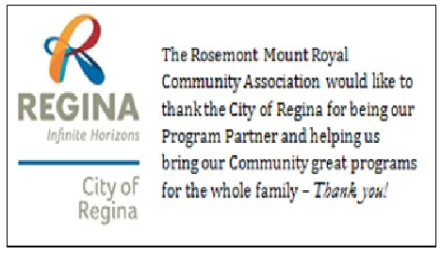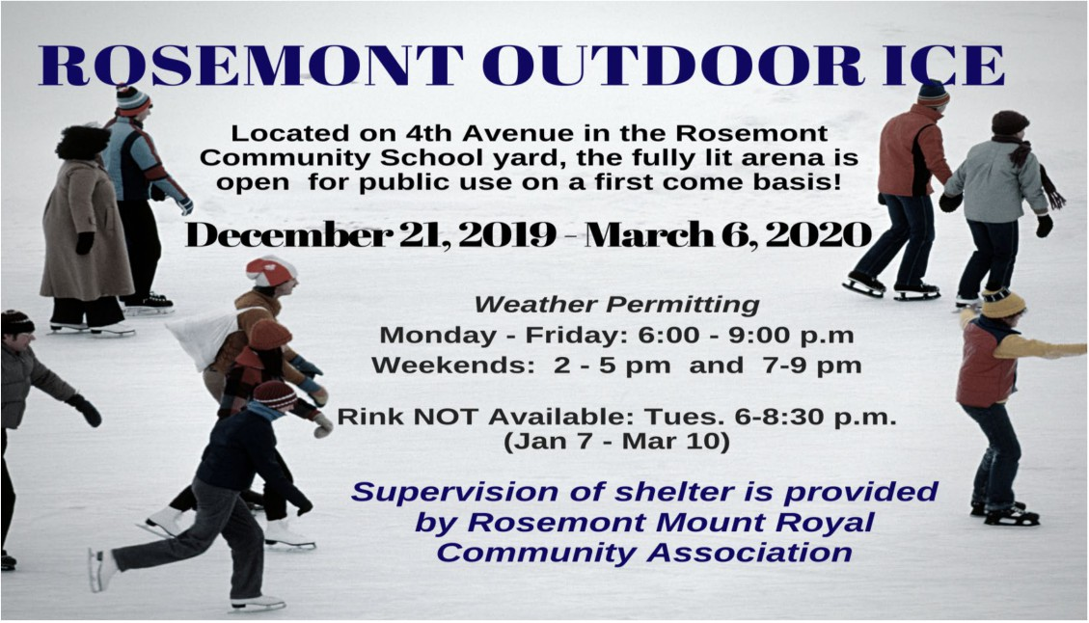T-BALL/SOFTBALL 3 - 14 YRS
Regina Northwest Sports Association is an affiliate of the West
Zone Board and operates a no-cut, equal participation sports
program.
Registration & Program Details: Online February 2020
www.rnwsa.ca
Programs and Cost: TBD. Costs vary by level. Full list online. Community Association Membership required ($10.00).

RMRCA Membership Card
Community Association Membership entitles you and your family to participate in numerous programs provided by our Community, other Communities, Zone Boards and Affiliated Groups.
One membership per family per year is required. Cost is $5. Forms available online, at Registration Night, or by mailing this form along with $5.00 and a stamped self- addressed envelope (if return mail is needed) to RMRCA Membership Coordinator, 6109 5th Avenue Regina, SK. S4T 6R8.
Name: _________________________________________________________________________________ Address: _______________________________________________________________________________ Postal Code:__________________________________ Phone: ____________________________________ Email: __________________________________________________________________________________ Do you want to receive RMRCA Newsletter and updates by email? Y N

www.rmrca.com Page 6

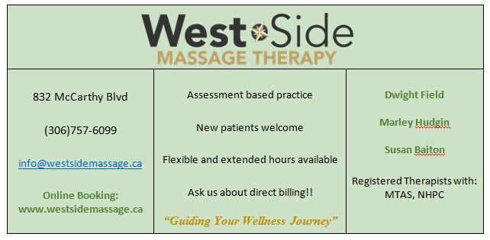

RMRCA Board of Directors - 2018/2019
Chairperson Theresa McQuoid 306-535-5595 tmcquoid@rentvictory.com
Vice Chair Alex Tkach alex.tkach@fqentertainment.ca
Secretary Dan Riess driess@hotmail.com
Treasurer Helen Adams 306-543-9152 helen.adams@sasktel.net
Membership Helen Adams 306-543-9152 helen.adams@sasktel.net
Outdoor Sign Glen Nichol 306-949-3195 cgnichol@sasktel.net
Facilities Helen Adams 306-543-9152 helen.adams@sasktel.net
Social Coordinator Dan Riess driess@hotmail.com
Communications Alex Tkach alex.tkach@fqentertainment.ca
Web Master Donna Inverarity donna.inverarity@sasktel.net
Promotions Elaine Dittmann 306-543-4402 edittmann@sasktel.net
Newsletter Editor Theresa McQuoid tmcquoid@rentvictory.com
West Zone Board Rep Andrew Nestor Andrew.nestor@staples.ca
Member-at-large Steve Bogues
Susan Bogues 306-949-1370
Reid Hill
Emma Trobiak
Marianna Topos Marianna_11@hotmail.com
Anya Syr-Costain
Programs Coordinator Theresa Porter tbaum3@hotmail.com
City of Regina Wendy Dumalski 306-777-7362 wdumalsk@regina.ca

EM: rmrca@myaccess.ca (General Inquiries) WB: www.rmrca.ca FB: RMRCA

w w w . r m r c a . c o m Page 7

w w w . r m r c a . c o m Page 8

